UNIVERSIDAD CRISTIANA DE LAS ASAMBLES DE DIOS

SCIENCES AND ARTS FACULTY

ENGLISH MAJOR BASED ON EDUCATION

|  |  |  |  |  |  |
| --- | --- | --- | --- | --- | --- |
| Grammar 1 | | | | | |
| Professor | B.A. Misael M. Sigüenza C. | Schedule | 6:30am-9:50am | Date | 01/14th,2014 |
| Student |  | | | | |

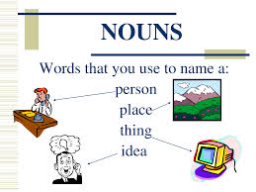

**[Nouns** are a [part of speech](http://en.wikipedia.org/wiki/Part_of_speech) typically denoting a person, place, thing, animal or idea**]**

The different types of nouns are defined below.

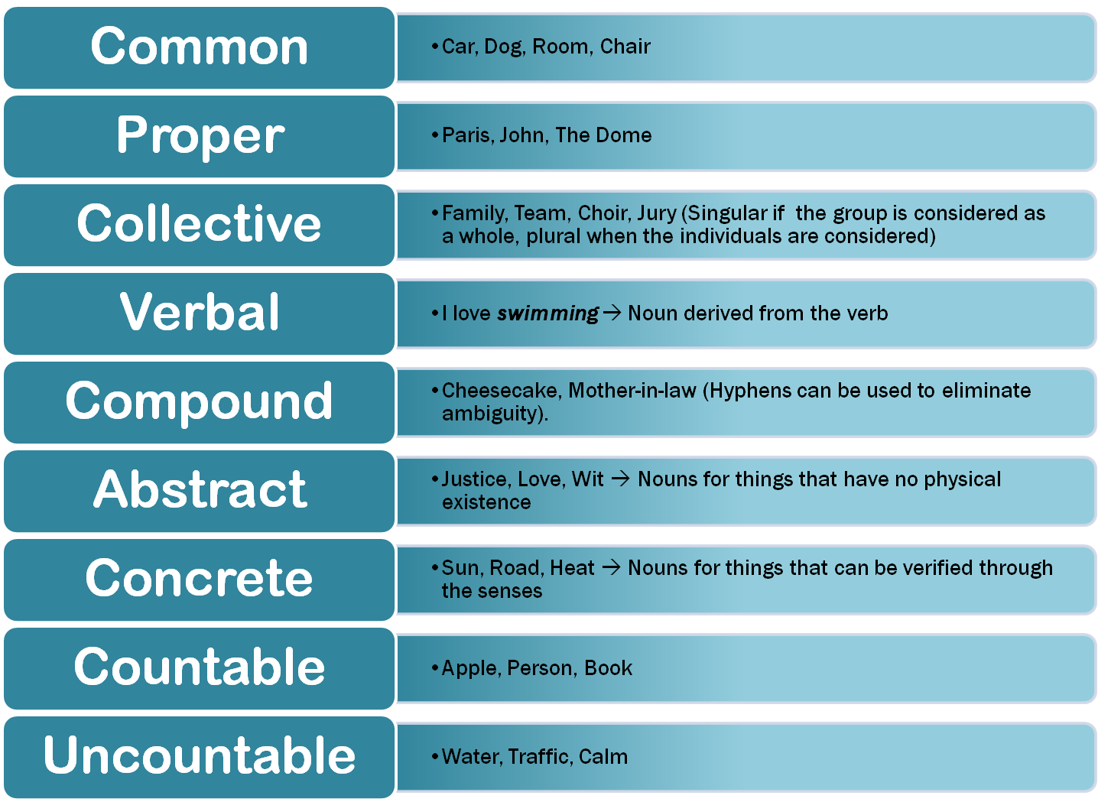

|  |  |  |  |  |
| --- | --- | --- | --- | --- |
| For example | | | | |
| People | Animals | Things | Places | Ideas |
| Man, girl, boy, mother, father, child, person, teacher, student | Cat, dog, fish, ant, snake | Book, table, chair, phone, laptop, tablet, cellphone | School, city, building, shop, bridge, street, mountain, river | Love, hate, idea, pride |

A *common noun* is a word that names people, places, things, or ideas, but it does it in a general way since it doesn’t give the specific name of the person, place, thing or idea. Note that a *common noun* begins with a lowercase letter unless *it* is at the beginning of a sentence.



[**Nouns**](http://www.chompchomp.com/terms/noun.htm) name people, places, and things. Proper nouns are different from common nouns because of two distinctive features: 1) it will name a specific item, and 2) it will begin with a capital letter no matter where it occurs in a sentence.

In other words, a proper name gives a particular name to a common noun, check the following examples.

|  |  |
| --- | --- |
| COMMON NOUNS | PROPER NOUNS |
| Cookie | Oreo |
| Person | Carlos |
| Professor | B.A. Sorayda de Granados |
| Restaurant | Pizza hut |
| University | U.C.A.D |



*Collective nouns*, name *groups* [*things*] composed of *members* [usually *people*]. Check out the chart below:

|  |  |  |
| --- | --- | --- |
| army audience board cabinet class committee company corporation | council department faculty family firm group jury majority | minority navy public school senate society team troupe |

Each noun from the list above is a single thing. That thing, however, is made up of more than one person. You cannot have a committee, team, or family of one; you need at least two people to compose the unit.

You can find a list of collective nouns in this link: <http://en.wikipedia.org/wiki/List_of_collective_nouns_in_English> or you can also see it and download it from the blog: *grammar1.webnode.es*



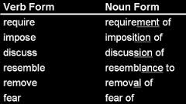 As the name indicates, verbal nouns are formed by inflection of a verb,usually by adding the suffix *–ing*, however, *“ing”* is not the only suffix that can be used to convert *“verbs”* into *“nouns”* , sometimes other suffixes will also appear in the sentences an will also be a noun, some of the most common suffixes are: [*tion, ion, sion, al, ment*]

**Here are some exaples:**

Arrive (verb) / arriv**al** (noun)  
decide (verb) / deci**sion** (noun)  
destroy (verb) / destruc**tion** (noun)  
fly (verb) / fli**ght** (noun)



A *compound noun* is one that is made of two or more simple nouns

|  |  |
| --- | --- |
| For Example….. |  |
| Simple Nouns | **Compound nouns** |
| Hair  Brush | Hairbrush |
| Can  Opener | Can opener |
| Tooth  paste | Toothpaste |
| In law  mother | Mother in law |



 Basically a concrete noun is one that you cannot experience with your senses, in other words it is one that you cannot see, smell, taste, hear or touch.

Examples of abstract nouns are: dedication, curiosity, trust, happiness, love, truth, peace, calm, terror, etc.



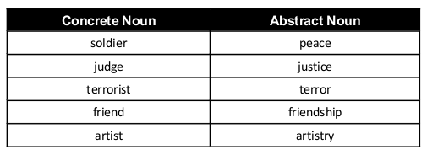 Concrete nouns are the opposite of abstract nouns because they name thing that you can see, smell, taste, hear and touch.

**Other examples of Concrete nouns are:** Movie, perfume, pizza, a song, trophy, etc.

You can find an enormous list of concrete nouns in this link: <http://www.writing.com/main/view_item/item_id/1757079-Concrete-Nouns-List>



Countable nouns are easy to recognize. They are things that we can count. For example: "pen". We can count pens. We can have one, two, three or more pens. Here are some more countable nouns: dog, cat, animal, man, person, bottle, box, litre, coin, dollar, cup, plate, fork, table, chair, suitcase, bag

Countable nouns can be singular or plural:

* My **dog is** playing.
* My **dogs are** hungry.

We can use the indefinite article **a/an** with countable nouns:

* **A** dog is **an** animal.

When a countable noun is singular, we must use a word like **a/the/my/this** with it:

* I want **an** orange. (*not* I want orange.)
* Where is **my** bottle? (*not* Where is bottle?)

When a countable noun is plural, we can use it alone:

* I like oranges.
* Bottles can break.

We can use **some** and **any** with countable nouns:

* I've got **some** dollars.
* Have you got **any** pens?

We can use **a few** and **many** with countable nouns:

* I've got **a few** dollars.
* I haven't got **many** pens.



Uncountable nouns are substances, concepts etc that we cannot divide into separate elements. We cannot "count" them. For example, we cannot count "milk". We can count "bottles of milk" or "litres of milk", but we cannot count "milk" itself. Here are some more uncountable nouns: music, art, love, happiness, advice, information, news, furniture, luggage, rice, sugar, butter, water, electricity, gas, power, money, currency

We usually treat uncountable nouns as singular. We use a singular verb. For example:

* **This** news **is** very important.
* Your luggage **looks** heavy.

We do not usually use the indefinite article **a/an** with uncountable nouns. We cannot say "an information" or "a music". But we can say **a something of**:

* **a piece of** news
* **a bottle of** water
* **a grain of** rice

We can use **some** and **any** with uncountable nouns:

* I've got **some** money.
* Have you got **any** rice?

We can use **a little** and **much** with uncountable nouns:

* I've got **a little** money.
* I haven't got **much** rice.

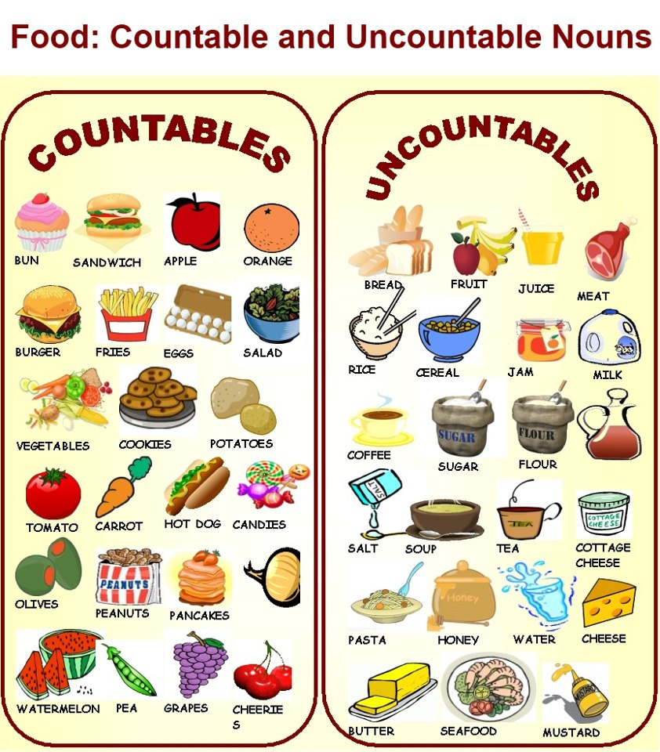Uncountable nouns are also called "mass nouns".

|  |  |
| --- | --- |
| **Countable** | **Uncountable** |
| dollar | money |
| song | music |
| suitcase | luggage |
| table | furniture |
| battery | electricity |
| bottle | wine |
| report | information |
| tip | advice |
| journey | travel |
| job | work |
| view | scenery |